Project Design Phase Solution Architecture

Date | 29 September 2026
Team ID | SWTID-2026-3894
Project Name | AI BLOGNEST API
Maximum Marks | 4 Marks

Solution Architecture:
The AI BlogNest API follows a modular and scalable architecture designed to automate blog content creation. The system begins with a user/application layer, where users provide a topic, keywords, preferred writing style, and content requirements. These requests are sent securely to the REST API layer, which handles authentication, request validation, and communication between the application and backend services. The AI processing layer analyzes the input and generates suitable blog titles, outlines, articles, summaries, and keywords using an AI language model. The generated content is then processed and formatted by the backend service before being stored in MongoDB, which maintains user details, requests, generated blogs, and content history. The API returns the final structured response to the requesting application in a convenient format such as JSON. This architecture allows AI BlogNest to support multiple applications, handle increasing users, and provide secure, reusable, and efficient content.

Example - Solution Architecture Diagram:

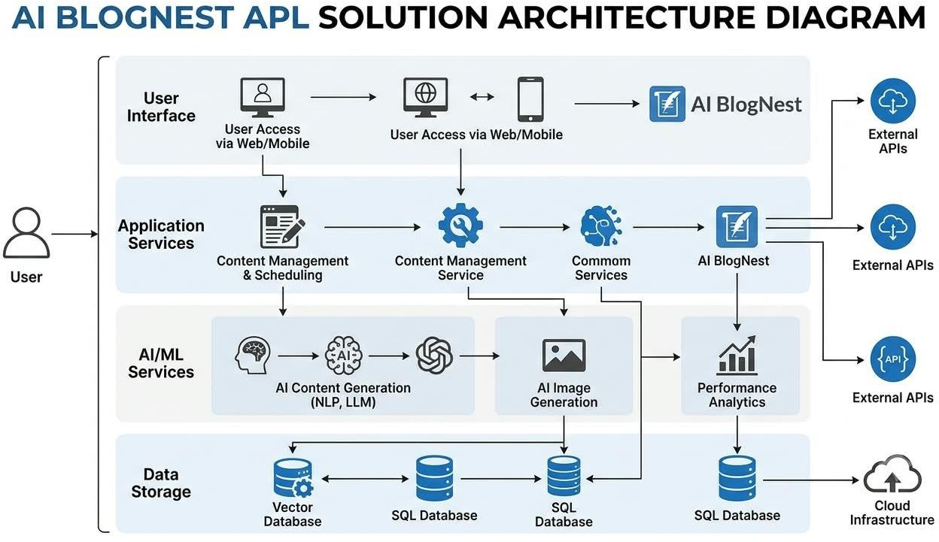

Reference:
https://aws.amazon.com/blogs/industries/voice-applications-in-clinical-research-powered-by-ai-on-aws-part-1-architecture-and-design-considerations/

